SnapWik: Android based application for Image & Text recognition

Adarsh Sai Gupta
Faculty of Computer Science
University of Windsor
Ontario, Canada
murugana@uwindsor.ca

Abstract—SnapWik is an image recognition application build on an android operating system, which uploads a soft copy of a captured image to the Google vision engine for detecting the labels by using machine learning techniques and based on finding this application shows those results on the screen. The results are subdivided into labels, texts and landmarks and each category has its confidence level from 0(low confidence) to 1(high confidence) for all the extracted data from this image. The application is useful in identifying unknown objects, like for tourists who want to find the name of the landmarks or an object as well. Similarly, it has more use cases for plant biologists for identifying flora and fauna of any specific plant species. As SnapWik also processes the text images, it will be helpful to understand foreign language signs on board for the travellers. These travellers can also take this app for their safari adventure where they can recognize animals, its name, class etc. by taking the picture using the inbuilt camera of this application.
Keywords—Image processing, Android, Google vision API, Machine Learning, confidence level, Image processing

Introduction

This report accounts for the development of SnapWik, which is an android based application. Our application can help in recognizing the object from the image and also recognizes the text from the image captured. SnapWik will be a new application implementing where we are using the image recognition system with the help of the Google Vision API as it contains the features of image recognition, label detection, and text recognition with detailing about the scanned object. Most other application in a similar category does either one of the jobs whereas our software plans to go all together for ease of use to end customer.

General Overview
“SnapWik” is a mobile application for image recognition in which we detect and identify an object. Once an object in the image is identified, we are connecting it to the Google Vision API to extract information about the same, like for animals which class it belongs, botanical names of flora and fauna and landmarks name, etc.
We have also implemented the text recognition in this application, where any hand-written text will be identified and processed through Google Vision API for more insight about it, what the project will deliver. Is it a new product or an extension of an existing one?
This project will deliver a mobile application based on Android Operating System, which will be used for recognition and describing any objects. SnapWik will be a new application implementing image recognition, text recognition together with detailing about the scanned object. Most other application in a similar category does either one of the jobs whereas our software plans to go all together for ease of use to end customer.

Motivation
The motivation behind any software product is to create a stepping stone for any technological advancement that will be beneficial for our society. An image recognition system designed by our team propels us to the same idea. Using this software, we can provide vision to computers and which can inspire many future possibilities in this field of study. Like Autonomous driving, which still is in the prototype stage, uses image recognition for making a distinction between static and dynamic objects. This image recognition technology is progress in the area of artificial intelligence, which as of current date, our software and technologist can only dream of.

Importance
SnapWik application hides the complexity of continuously evolving machine learning models and image processing algorithms.
These models will improve overall system accuracy – especially as far as to object detection – since new concepts almost certainly will be introduced in the system over time[1].
Our application recognizes the famous landmarks, personalities, all the objects, and it also recognizes the text from the image.

Contribution
The contribution of the team members towards different parts of the project are given underneath:
- Coding, Logic Design and Documentation - Anas Shah and Adarsh Sai Gupta
- Code Integration and User Interface design - Adarsh Sai Gupta and Anas Shah
- Testing, Documentation, Minutes of Meetings - Swathi Reddy and Kaushal Tank
- Testing, Documentation and Report - Kaushal Tank and Swathi Reddy

Requirement Analysis
Our application is more focused on the educational model rather than sell to the customer model. It should be able to run on the Android-based operating system. With our application, anyone can identify some unknown objects like (animals or plants or landmarks) in new countries of which they are not aware of. For example, an animal found in North and South America but not in any Asian countries, similarly many florae, fauna, birds, etc. A tourist can make use of this app for scanning and identifying these objects and become aware of the facts about the same. Our application should also recognize the text from the image which helps the users for text recognition.

Literature review
In research conducted by Swati D., Sneha D., Megha S. and Seira T. [2]. There are numerous applications and websites of text recognition, label detection, and face detection separately, but the paper gives information about how to combine all the three features using an image recognition system that uses Google cloud vision API. This combined system can be used for organization, computer software, for security purposes and in the government field. Image recognition is the ability of any device to receive and interpret pictures which may be inputted from multiple sources like photographs and significant screen devices. Recognition of handwritten, machine characters, labels, faces and emotions of the face are an emerging area of research and finds extensive applications in banks, offices, and industries, etc.

Project details and methodology
This part of the report covers project details and the methodology that has been used for the development of the project

Definitions
Below are some basic definitions that are needed for the proper understanding of our project.

- Image Processing: Image processing is a method to perform some operations on an image and thereby to extract some useful information from it.[3]
- Image Recognition: Image recognition is the ability of software to identify objects, places, people, writing and actions in images. Computers can use machine vision technologies in combination with a camera and artificial intelligence software to achieve image recognition.[4]
- Artificial Intelligence (AI): Artificial Intelligence is a technology that enables a computer to think or act like a ‘human.’ [5]
- Machine Learning (ML): Machine Learning is an application of AI that provides the ability to automatically learn and improve from experience without programmed in any system.[6]
- Application Program Interface (API): An API is a set of routines, protocols, and tools for building software applications. An API specifies how software components should interact.[7]

Specification
Android studio is required to be installed on the operating system. For running an android studio, we need 2 GB RAM minimum, but 4 GB RAM is recommended. Also, 400 MB hard disk space plus at least 1 GB for Android SDK, emulator system images, and caches and JDK [8].

Architecture
SnapWik is the android application that is integrated with the Google Vision API for detecting the object or text from the image captured. The user searches for the image from SnapWik, and the captured image is uploaded to the cloud storage for determining the object, and the cloud storage is then connected to the Google App Engine to push the notification to the app engine endpoint [9].
Below is a figure that shows the precise flow of how the object of the image is determined from the google cloud to provide the results to the user:
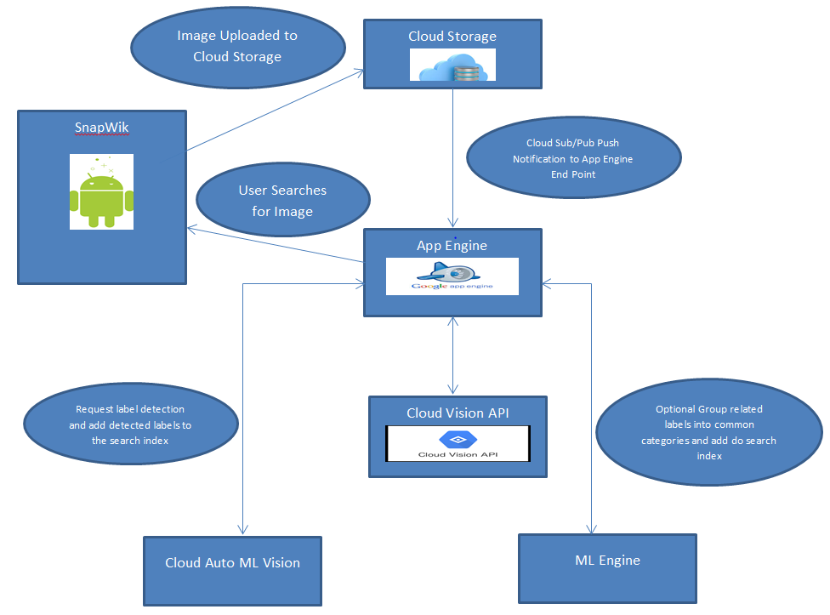
Figure 1: System Architecture [9]
The app engine that is interlinked with Cloud Vision API will request the label detection to cloud auto ML Vision and adds the detected label to the search index back to the app engine. It also connects with the ML engine when the labels are of standard categories and adds to the search index back to the app engine, and this is the voluntary group that the app engine does. From this, it determines the object from the cloud storage information and then returns the results to the application.

Platform
Android Studio is an open-source integrated development environment (IDE) for the Android stage which disentangles application improvement. There are many platforms, like Android Studio, where even beginners can get into Android development. Android Studio is a cross-platform integrated development environment (IDE) for developing on the Android platform. It is written in Java and is accessible for Linux, Windows just as for Mac OS X. Android Studio offers a superior Gradle build environment, smarter short cuts, an improved user interface (UI) designer, a superior memory screen, an improved string translation editor and better speed [10].

It has built-in for the Google Cloud Platform, making it simple to coordinate Google Cloud Messaging and App Engine. It likewise accompanies inline troubleshooting and performance analysis tools. Android Studio has Android Virtual Device (AVD), which accompanies emulators for Nexus 6 and Nexus 9 gadgets. It additionally offers to fabricate variations and the capacity to produce many apk files. Whenever one compiles a program, the configured lint and IDE inspections run consequently [10].

Design

SnapWik is powered by Google Vision API, which is Google’s deep learning model for the detection of the static object and helps to implement vision capabilities to our application. It is capabilities include object detection in an image, Label detection, face and landmark detection. Thanks to Machine learning vision implemented by the Google cloud platform, this application can make the distinction in a face and a landmark and even works on explicit content as well[11].

SnapWik front end UI allows a user to capture a real-time image or upload an old image to Google's cloud storage. Once the image is uploaded, it is being pushed to the App engine for further processing. App Engine uses Machine learning vision to detect the label in the image, be it a landmark, object or text. Because of Google’s substantial training data set, this engine can make a distinction in the label provided by our image[11].
This is the part of the deep learning implementation where extensive test data set will hold the label information of an object, and once uploaded, an image is identified with the label, which becomes our training data set. ML Vision then tests its model on training data set and based on the result; it assigns the confidence level to each object range from 0(no confidence) to 1(high confidence) [11]. Results are displayed on SnapWik application in a graphical cloud (Tag Cloud) form, where the size of each word represents their confidence level.

Methodology
Our team has used Unified process methodology for building this software as its more Use-case and risk driven approach and SnapWik being a new application, and there are various use-cases and risk which can be identified at several stages of the software progression. Hence, building this software in phase by phase is the best approach in my team’s opinions.

Experimental setup
This section focuses on Implementation, testing, challenges and findings in our project.

Implementation
To access Google APIs utilizing the official client SDKs, create a service object based on the API's discovery report, which depicts the API to the SDK. It should fetch it from the Vision API's discovery service. Through the image recognition framework, a picture is transferred to the mainframe of the recognition system; then, it is consequently uploaded to the Cloud Storage with text, object and face in any image (a message that shows up in the image itself). A Cloud Function is activated, which utilizes the Vision API to separate the text, object, face and lines the text to be converted into the arranged outcomes. For each translation, a Cloud Function is activated which utilizes the Translation API to translate the text and line it to be saved to Cloud Storage. For each translated text, a Cloud Function is activated which saves the translated text to Cloud Storage. For face and label detection, the device takes a delicate duplicate of the image and extract result by utilizing the Google cloud platform. The coding of API is done on the python language by the Google administrations. To utilize this API, we need to use another language for connectivity purposes like Android, PHP, and Python, and so forth to set a base or a platform to run API [12].

Below is a figure that shows the implementation of the application using the Google API:

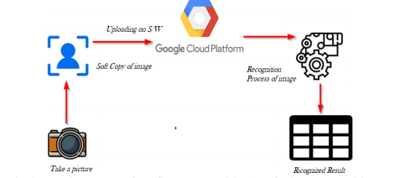
Figure 2: Working of Google cloud vision API [12]

Testing
We have done testing for the SnapWik android application by providing various types of input images and input images that have text to the system to provide test cases. Performance testing was also done to the application as its response time is efficient. Below are the various test cases that have been tested with the android application.

- Test Case 1: When the captured image has an object, and it identifies the object and provides information about the same.
- Test Case 2: And if the image has text, then it recognizes the text and provides results.
- Test Case 3: But when the handwritten text is provided to the system, it does not provide accurate results and is not reliable.
- Test Case 4: When a blurry image or a far distant object is captured, the application cannot identify the object.
- Test Case 5: And it also cannot identify the object when the image has both object and text in the image as it identifies only the text but not the object.

As mentioned by the principles of Software engineering, complete testing for any system is impossible. Despite that, we have made considerable efforts to provide various test cases in the provided project completion time.

Challenges
- Our team faced many challenges with our development progress, especially in the area of configuring our Cloud API and integrating the same in SnapWik.
- The challenge faced by us was designing the Android-based application, where we wanted to implement the functionality of a popup after the result is retrieved from the cloud to provide the user with all the necessary information and a scrollbar in our application if the result text is too long to read in a single page.
- The next major problem faced was integrating native camera to our application.
- Another challenge was text extraction from the Result received from the Google API. This keyword or tags extraction is crucial for our application implementation, and we need those <tags> based on the level of confidence percentage. For example, an image with cat image shows results with various levels of confidence, but we need to extract the keywords or tags based on the highest level of confidence, i.e. <cat> with 99.6% confidence. This situation is not consistent with all the results as with any landmark like images; there is a 96% confidence level with the exact name and 99% confidence with the keyword like <statue>. This behaviour for not being constant was a challenge for our team.

Findings
An image recognition software from a layman term is a tool to process an image and produce the information of an object in that image. We knew that Google Vision API does this processing, but how this is done from the perspective of a computer scientist is a new finding for our team.

An image recognition engine uses a machine learning model to train its data set from the thousands of images on the internet and store the labels from these images as a benchmark for any other similar image. This is called classification, which is a kind of supervised learning, where user intervention is required to train the model and once trained, it specifies the new data or the labels to which class it belongs.

To align these findings with our SnapWik application, a soft image is uploaded to ML model, which is already has been trained with massive training data set, it processes the image by finding the labels and classify the image to it respective class, as this model knows from before which label belongs to which class. Moreover, based on this, it displays the results to the end-user with a certain level of confidence level to denote how accurate the model prediction is.

conclusion
The project has been expertly finished by all team members while keeping all deadlines and fulfilling all objectives mentioned at the requirement analysis phase. Multiple phases of software development life cycle like Requirement Analysis, Planning, Design, Implementation and Testing for various iterations of the application are carried out to ensure the highest quality software. The project is not constrained to this phase as there are upgrades that can be implemented in further improvement of the project.

Future work
One of the most critical aspects of SnapWik is its dependency on Google Cloud vision API, which is very costly for a small business to provide services to its customers. If one of our customers install this application, their id will be connected to the admin console traffic and the number of the time, he/she makes a request, this engine will be charging for it.

So, keeping that in our mind we are proposing our future enhancement, where we plan to replace the vision engine with our home-made machine learning-based algorithm, which will not be as efficient compared to Google’s with their vast training data set but will be very cost-effective for the customers and the businesses providing these services.

Google’s machine learning uses other training sets to train itself with the set of label for a particular image, like for example cat, and whenever a new image of cat is requested from this engine to reply, it checks the labels on the image and search its database for the name of this kind of labels and once found, it shows the output. This method has an almost 99% accuracy rate because of massive Google’s training set data, which can extract labels from the images all over the internet. Our home-made engine might not be that accurate, but by storing the images we are sending to vision engine API, we might be able to achieve higher accuracy. Our algorithm will be trained with the images in our database for its learning purposes, and soon, we might be able to identify an image by using this algorithm at a much cheaper rate.

Acknowledgement
We want to offer our thanks towards our professor and mentor, Dr. Pooya Moradian Zadeh, Assistant Professor at the University of Windsor, Canada, who has given us enormous guidance, support, suggestions and recommendations. Without his assistance, we could not have built up this project up to the present standard.

References
- A. Casalboni, “Google Vision API: Image Analysis as a Service,” Cloud Academy, 21-May-2019. [Online]. Available: https://cloudacademy.com/blog/google-vision-api-image-analysis/. [Accessed: 28-Nov-2019].
- S. Dewangan, S. Dey, M. Sahu, and S. Tak, “Image recognition system,” International Journal of Advance Research Ideas and Innovations in Technology, vol. 5, no. 2, pp. 1788–1791, 2019.
- G. Anbarjafari, “1. Introduction to image processing,” Sisu@UT. [Online]. Available: https://sisu.ut.ee/imageprocessing/book/1. [Accessed: 28-Nov-2019].
- “What is Image Recognition? - Definition from Techopedia,” Techopedia.com. [Online]. Available: https://www.techopedia.com/definition/33499/image-recognition. [Accessed: 28-Nov-2019].
- J. Frankenfield, “How Artificial Intelligence Works,” Investopedia, 18-Nov-2019. [Online]. Available: https://www.investopedia.com/terms/a/artificial-intelligence-ai.asp. [Accessed: 28-Nov-2019].
- “Machine learning,” Wikipedia, 27-Nov-2019. [Online]. Available: https://en.wikipedia.org/wiki/Machine_learning. [Accessed: 28-Nov-2019].
- V. Beal, “API - application program interface,” What is API - Application Program Interface? Webopedia Definition. [Online]. Available: https://www.webopedia.com/TERM/A/API.html. [Accessed: 28-Nov-2019].
- “Android Studio,” Wikipedia, 14-Nov-2019. [Online]. Available: https://en.wikipedia.org/wiki/Android_Studio. [Accessed: 28-Nov-2019].
- “Processing User-Generated Content Using the Cloud Video Intelligence and Cloud Vision APIs | Solutions | Google Cloud,” Google. [Online]. Available: https://cloud.google.com/solutions/processing-marketing-submissions-using-video-intelligence. [Accessed: 28-Nov-2019].
- Sakshi VaidThe author is a FOSS enthusiast and loves learning about the latest technologies. She is presently working on Android and blogs at sakshivaid.wordpress.com, “Android Studio: A Platform for Android Development,” Open Source For You, 24-Nov-2017. [Online]. Available: https://opensourceforu.com/2015/11/android-studio-a-platform-for-android-development/. [Accessed: 28-Nov-
- 2019].
- “An image search application that uses the Vision API and Cloud AutoML Vision | Solutions | Google Cloud,” Google. [Online]. Available: https://cloud.google.com/solutions/image-search-app-with-cloud-vision. [Accessed: 28-Nov-2019].
- “Quickstart: Using Client Libraries | Cloud Vision API | Google Cloud,” Google. [Online]. Available: https://cloud.google.com/vision/docs/quickstart-client-libraries. [Accessed: 28-Nov-2019].

